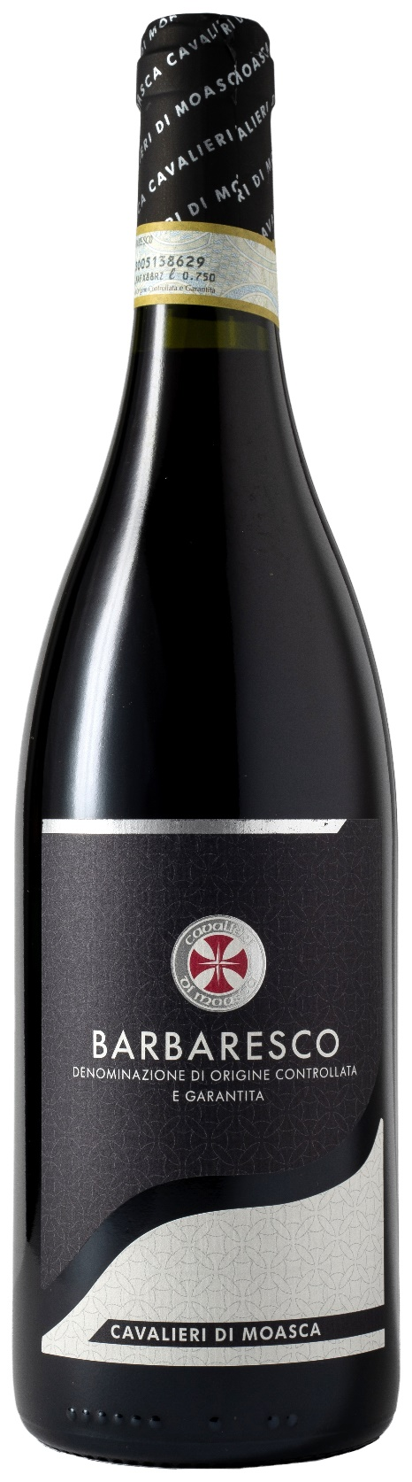
BARBARESCO DOCG – CAVALIERI DI MOASCA

Grape: Nebbiolo 100%
Alc. Vol.%: 14,5
Vintage: 2022
Residual sugar g/l: 2,0
Total acidity g/l: 5,5
Region: Piedmont
Production zone: Vineyards in the area of Barbaresco (Cuneo)
Capacity: 750ml

CHARACTERISTICS

Vinification: At a controlled temperature. The peel maceration takes 12 days and is made in steel tanks. For a better extraction of colour and tannins it is pumped over several times
Aging: 26 months in oak barrels and steel tanks
Yield per ha: 8000kg
Colour: Shiny red with garnet reflections
Bouquet: Delicate, intensive and complex
Flavour: Dry, smooth and elegant, with strong but well-balanced tannins

SERVING SUGGESTIONS

Best enjoyed with red and white meat, venison and cheese.
Serving temperature 18-20 °C
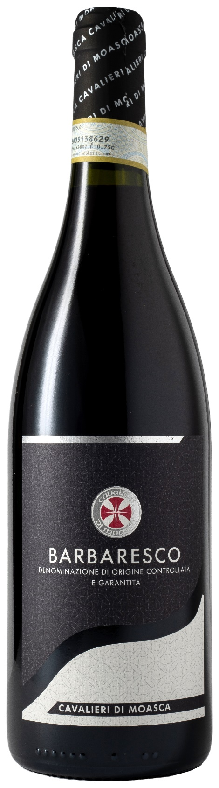
TECHNICAL INFORMATION / PALLETIZING

Size 750ml:
Article Nr. V06006A
GTIN-13 bottle 8017868002147
GTIN-13 carton 8017868001973
Closure Cork
Bottles / carton 6 bottles
Pallet size 80x120cm
Cartons/layer 21
Cartons/pallet 105
Kg/carton 8,1
Kg/pallet 870

Contains sulphites
GMO Free
Revisione 01. 21.04.2026

